PLESSEY BOWLS CLUB FINALS WEEKEND RESULTS

MENS SINGLES CHAMPION – MARTIN BUTCHERS

LADIES SINGLES CHAMPION – DEBBIE CREWS

3*7 SINGLES – JOHN CREWS

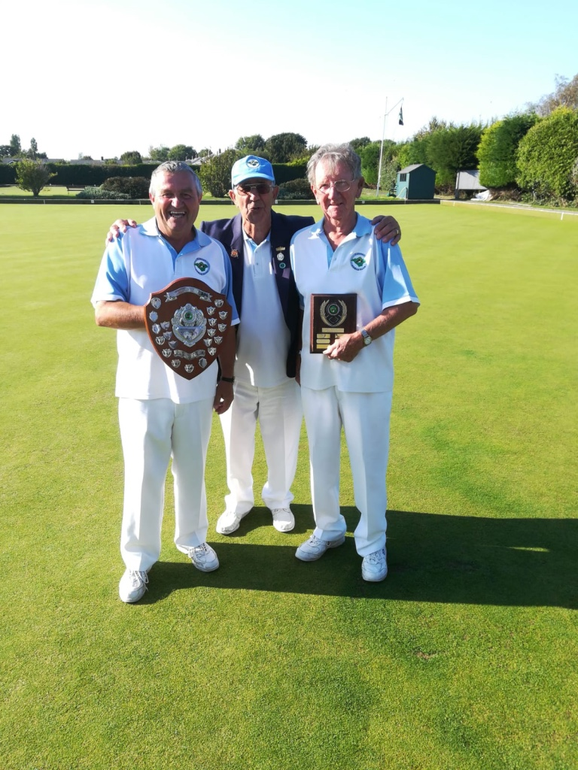

SINGLES PLATE – LEN MARTIN

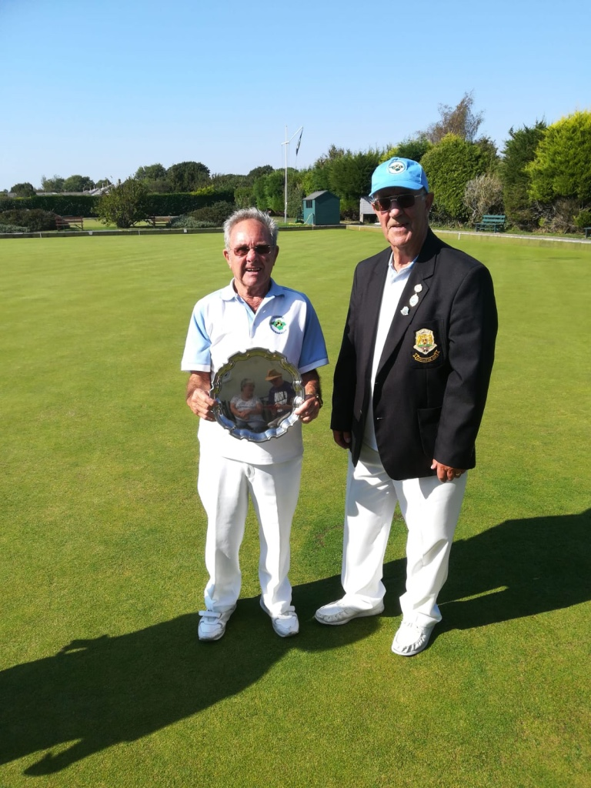

MENS PAIRS WINNERS – MIKE COX, RAY BLANCHARD

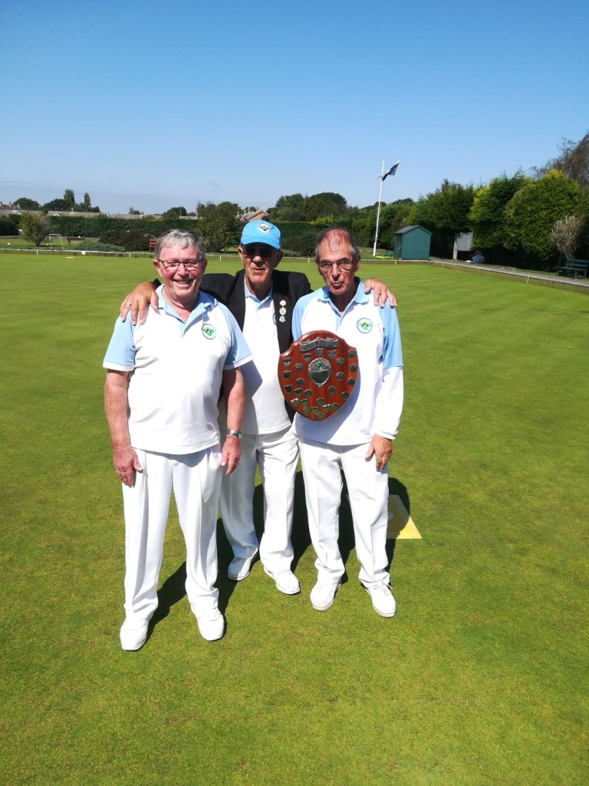

LADIES PAIRS WINNERS – DEBBIE CREWS, DENISE BUTCHERS

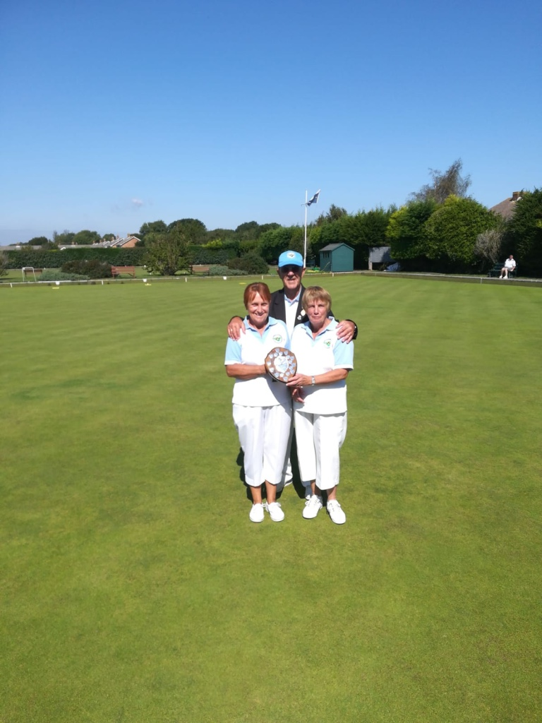

MIXED PAIRS – JOHN AND DEBBIE CREWS

AUSTRALIAN PAIRS – BARRY BRIDGEMAN AND STEVE CROCKETT

100 UP PAIRS – VAL AND DEREK STEVENS

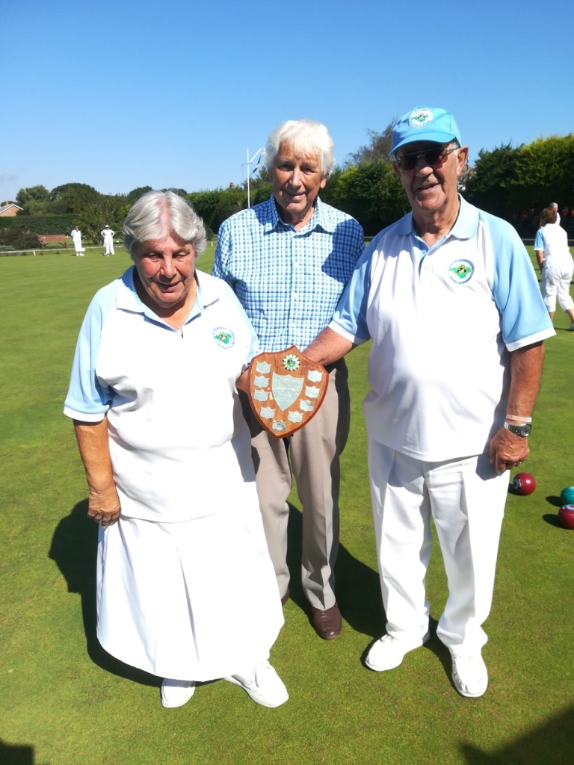

TRIPLES – ROY SMITH, MIKE CHAPMAN, BARRY BRIDGEMAN

FOURS – LEN MARTIN, JOHN NELSON, PETE LEWIS, PETE CLAYTON

